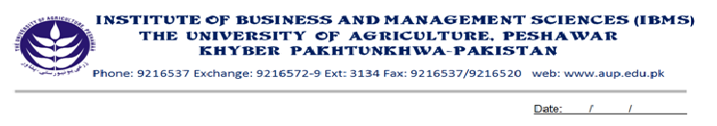
Program: BS (IT)-III

Course Name: Principles of Management
Course Code: MG- 401
Course Hours: 03
Total Weeks: 16
Total Hours: 48

Course Objectives

Being the Institute of Business and Management Sciences, the IBMS/CS provides education and training in Business Administration & Management to turn out skilled & qualified managers & administration in both the public and private sectors. Along with other subjects Management is included at the graduate and post-graduate levels in the IBMS/CS. It is a prolific subject & has diverse dimensions to serve the varied needs of management in modern times.

Week 1: An Overview of Management
Definitions of Management
Characteristics of Management
Different between Management and Administration

Week 2: Functions of Management
Functions a brief Treatment
Planning, Organizing, Staffing
Directing, Controlling, Coordination

Week 3: Principles of Management
Taylor’s Principles
Fayol’s Principles
General Principles

Week 4: Importance and Scope of Management
Importance of Management
Scope of Management
Week 5:
Nature of Management
Management as an art
Management as a Science
Management as a Profession

Week 6: Review
Examination
Allocation of Assignment

Week 7: Planning
Definition
Nature and Characteristics
Importance of Planning
Limitations of Planning
Essentials of a good Plan
Steps in Planning Process
Types of Planning

Week 8: Organizing
Nature and Importance of Organization
Steps in the Process of Organization
Formal and Informal Organization
Principles of Organization

Week 9: Communication
Definition of Communication
Process of Communication
Importance of Communication
Types of Communication
Barriers to Communication
Over Coming the Barriers
Characteristics of a good Communication System

Week 10:
Staffing
Definition of Staffing
Sources of Recruitment
Steps in Selection Process
Orientation or Induction
Training and Education
Types and Methods of Training
Week 11:
Directing / Direction
Definition
Nature and Importance
Principles & Techniques
Week 12:
Leadership
Definition
Traits / Qualities of a Successful Leader
Leadership Styles
Function of Leader Ship

Week 13:
Decision Making
Meaning and Elements of Decision Making
Importance and Process of Decision Making
Salient Features of a good or an Effective Decision
An Effective Decision Making
Week 14:
Controlling
Definition of Controlling
Characteristics of Controlling
Objectives of Controlling
Steps in the Process of Controlling
Essentials of an Effective Control System
Week 15:
Motivation
Meaning and Importance
Financial and Non Financial Incentives
Theory X and Theory Y
Maslow’s Need Priority Model
Week 16:
Seminars, Assignments and Presentations

Total Marks: 100

Recommended Books

- Principles and Practice of Management 1998 Edition, Terry, Prentice Hall USA.
- Practice of Management, 1997 Edition P.F. Duck Ker, Macmillion, London.
- Fundamentals of Management 2004 Edition, Prof. Fazli Wahid IBMS/CS Agricultural University Peshawar.

